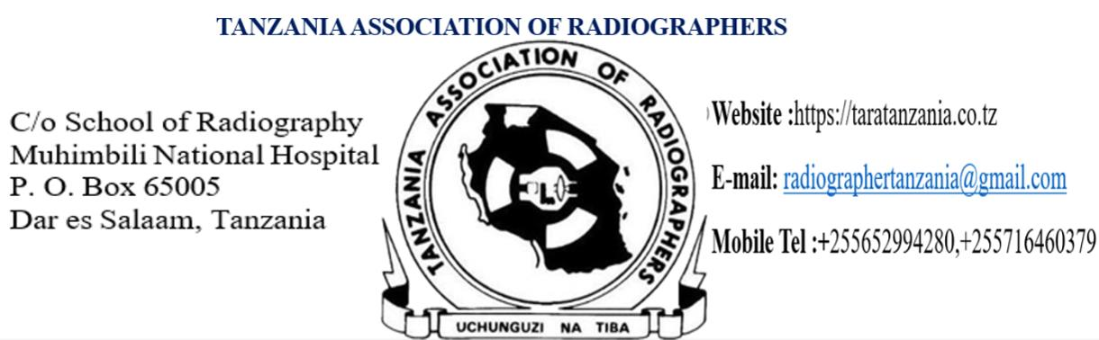
Ref: TAR/GC/__/2026
Date: 22nd August, 2026
To:
THE DIRECTOR
[INSTITUTION NAME]
P.O. BOX [BOX NUMBER]
[TOWN / REGION]
Dear Sir/Madam,
RE: INVITING [NAME OF PARTICIPANT] TO ATTEND THE 50TH TARA SCIENTIFIC CONGRESS (TARASCO) & AGM -2026
I am pleased to inform you that the Tanzania Association of Radiographers (TARA) is convening its 50th TARA Scientific Congress (TARASCO) under the theme “Upholding Patients’ Care and Integrating Radiography into the Heart of Sport Medicine Through a Multidisciplinary Action.”
The Scientific Congress is scheduled to take place from 11th to 13th November 2026 at Tanga Resort Beach Hotel, Tanga Region.
In attendance will be Radiographers, Radiotherapists, Nuclear Medicine Technologists, Sonographers, and other multidisciplinary medical professionals in sport medicine from across Tanzania, East Africa, and Central Africa. About 600 participants are expected to attend.
This congress will offer the opportunity to strengthen Radiography in sport medicine and governance capacities among Radiographers, Medical Imaging Professional staff and other multidisciplinary medical cadres, working alongside the Ministry of Sport, Ministry of Health, and football affiliation boards, to enhance the effective delivery of quality and sustainable Radiography services in sport medicine, in line with existing laws and regulations.
We kindly request you to release and sponsor [Name of Participant], Radiographer(s) in your institution, to attend this important scientific conference as part of professional developments. Please find attachment for TARASCO contribution cost and fees according to membership status. We are looking forward for positive responses.
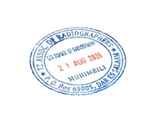
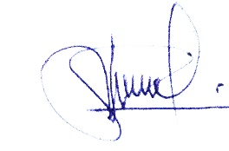
Regards,

Lenganwa Samwel
Secretary General, TARA
radiographertanzania@gmail.com

